10. Nerve Cells and the Transmission of Impulses *Chapter 39*

______________________________________________________________________________

I. Introduction

A. Integration

1. Nervous system

2. Endocrine system

B. Functions of Nervous System

C. Complementary Structures

II. Neuron Anatomy *(930-935)*

A. General Structure

B. Diversity of Structure

1. Sensory neurons

2. Motor neurons

3. Interneurons

C. Supporting Cells

III. Transmission Along an Axon *(935-941)*

A. Polarization of Resting Axon

1. Ions and the nature of polarization

2. Maintaining ion concentration gradients

3. Resting state potential

B. Action Potential

1. Reversal of polarization

2. Mechanism of reversal

3. Restoration of resting state polarity

4. Restoration of resting state ion concentrations

5. The trigger for depolarization

C. Characteristics of Axonal Transmission

1. Self‑propagation

2. All or none response

3. Speed of transmission

D. Coding the Intensity of a Stimulus

IV. Transmission between Neurons *(941-947)*

A. Synapses

B. Stimulatory Transmitters

1. Release of transmitters

2. Depolarization of receiver

3. Neurotransmitters

C. Inhibitory Transmitters

1. Presynaptic inhibitors

2. Postsynaptic inhibitors

D. Principle of summation

10-1

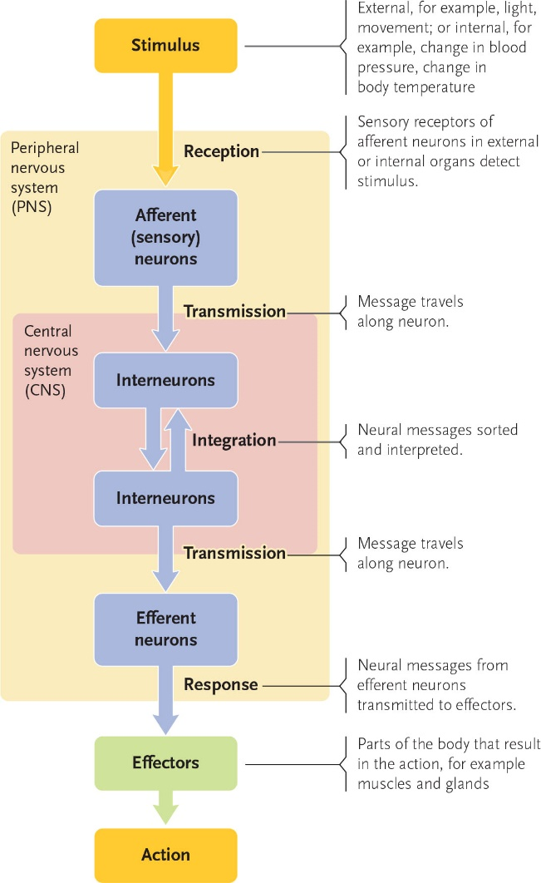

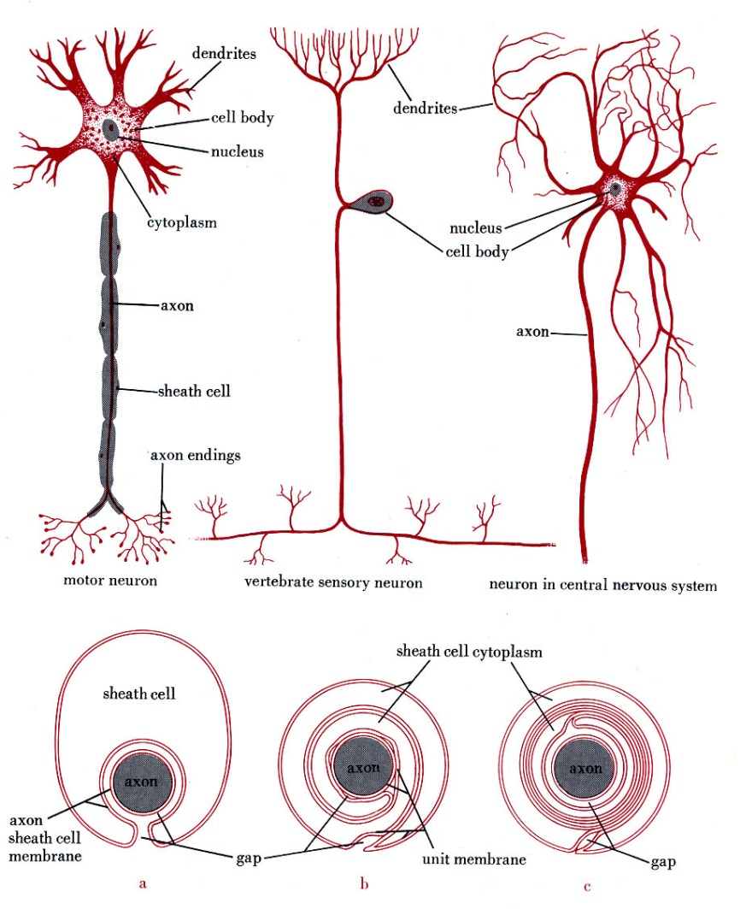

10-2

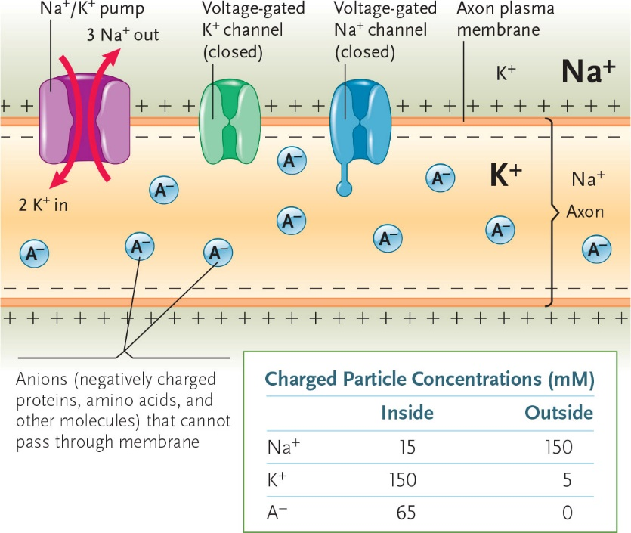

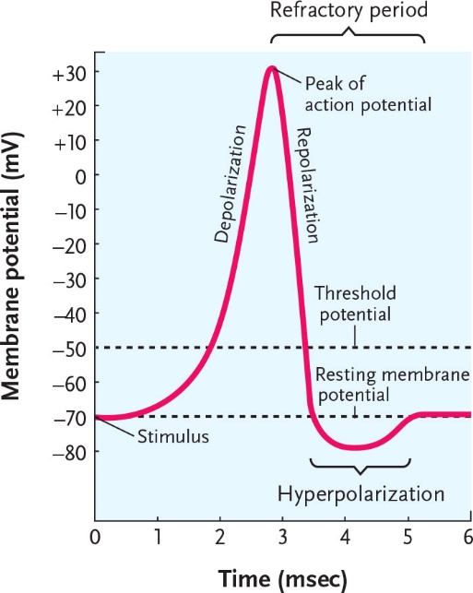

10-3

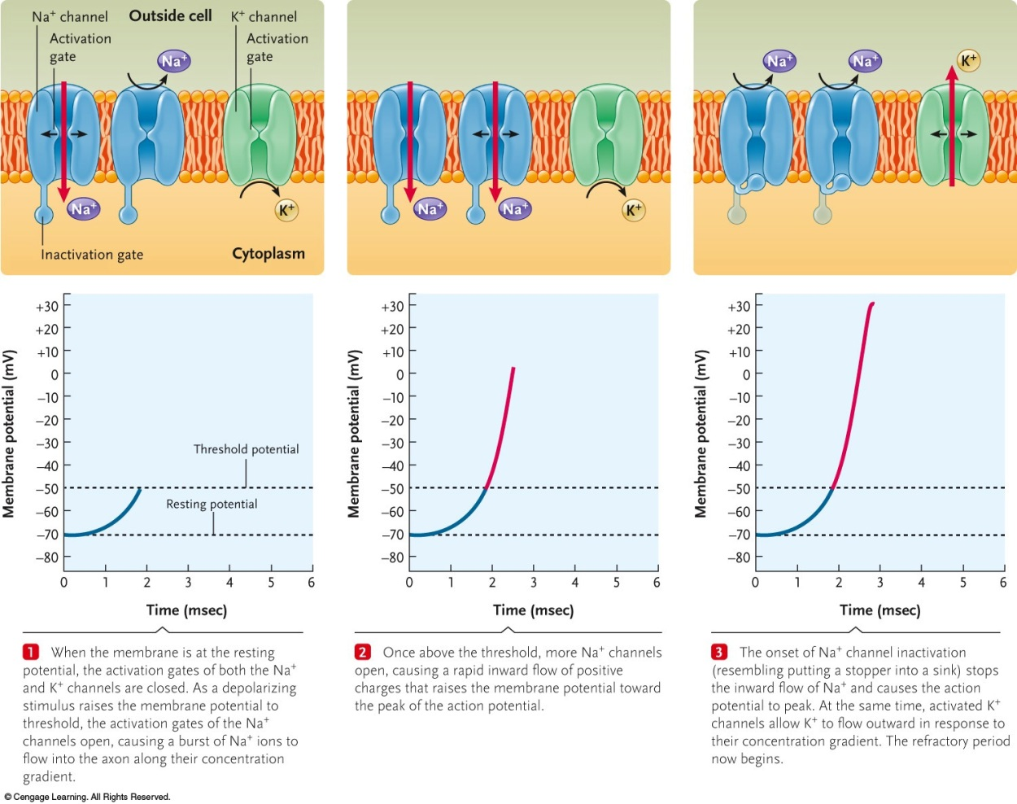

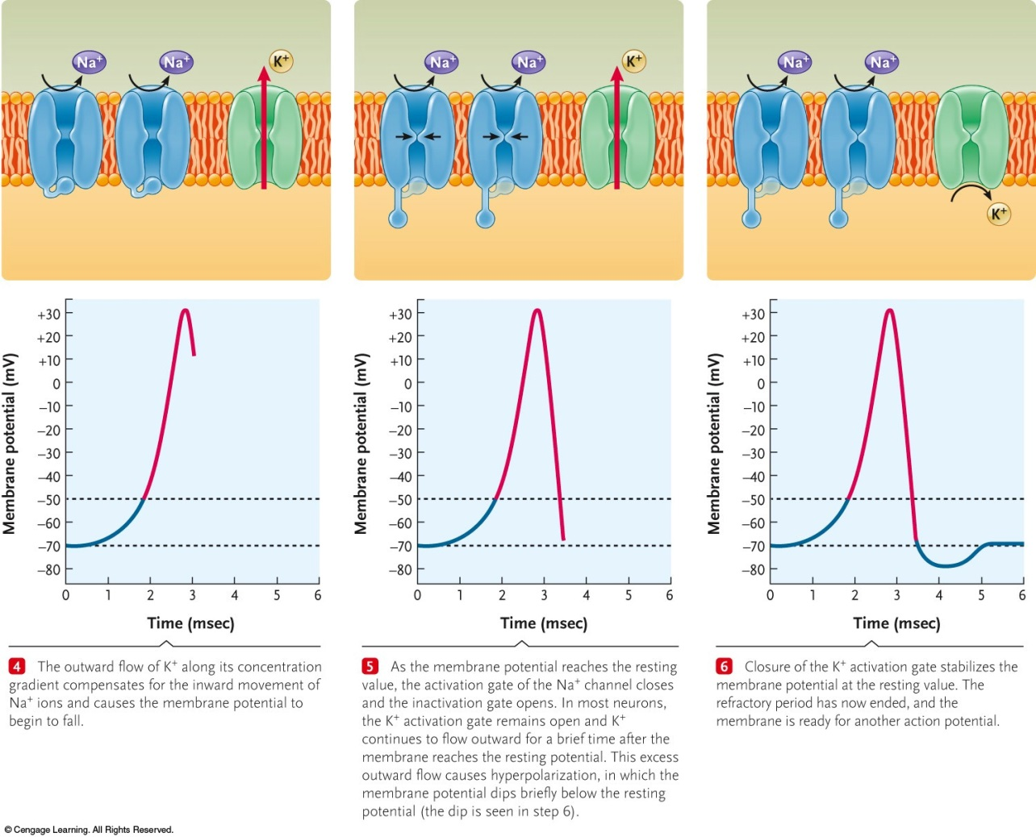

10-4

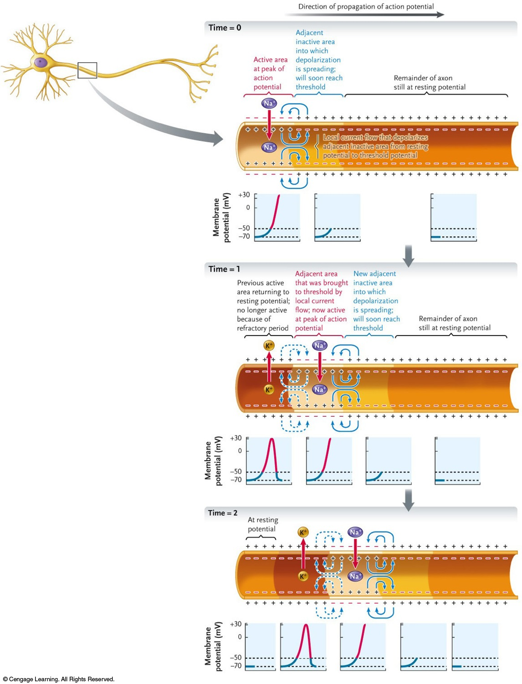

10-5

